**1-create new repository called chat in github**

**2-python –m venv venv**

**3- venv\Scripts\activate**

**4-pip install django**

**5-django-admin startprojet studybud .**

**6-python manage.py startapp base**

**7-add base app to installed_apps in settings.py**

**8-pip install pillow**

**9-models.py:**

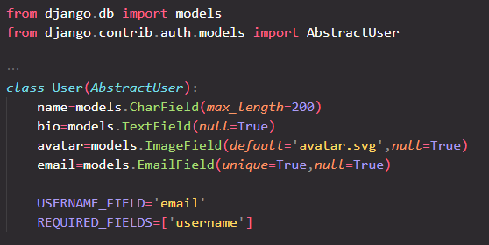

**10-settings.py:**



**11-python manage.py makemigrations**

**12-python manage.py migrate**

**13-python manage.py createsuperuser**

**14-models.py:**

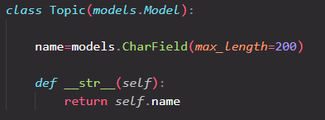

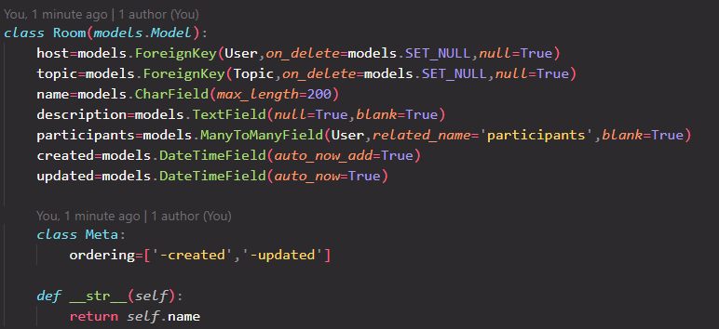

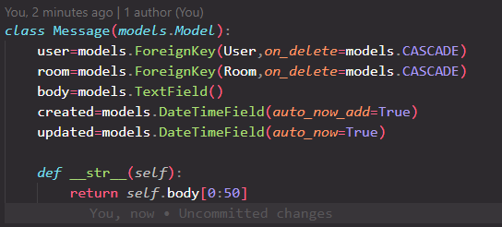

**15-makemigration and migrate.**

**16-create template folder insie base app and create base folder inside it:**

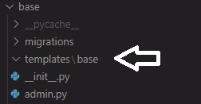

**17-move index.html file from Requirements folder inside templates/base folder:**

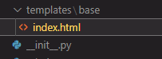

**18-navbar.html**

**Inside templates folder and just cut header section from index.html and paste it inside it:**

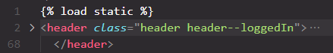

**19-main.html:**

**Create inside template folder and it contains head section and empty body and script:**

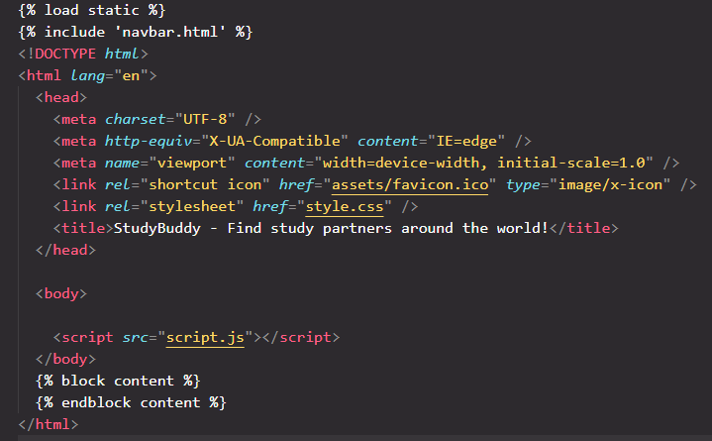

**20-index.html:**

**Just keep main section:**

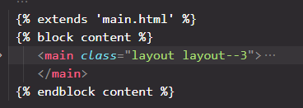

**21-create static folder in the root and create styles,js,images folder inside it:**

**22-copy style.css file from Requirements folder inside styles folder.then copy script.js file from same where to js folder and copy images and icons from Requirements/assets to images folder:**

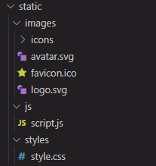

**23-settings.py:**

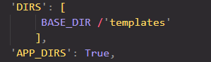

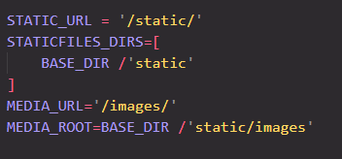

**24-urls.py project:**

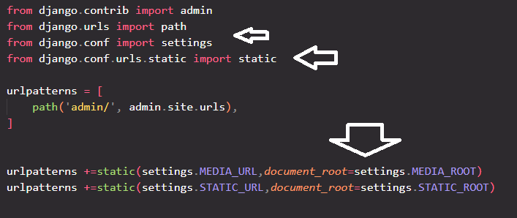

**25-rename index.html to home.html:**

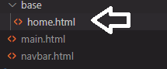

**26-views.py base app:**

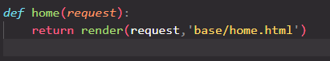

**27-create urls.py file inside base app:**

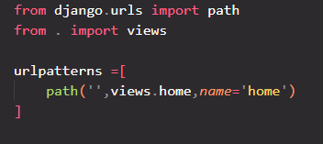

**28-urls.py project:**

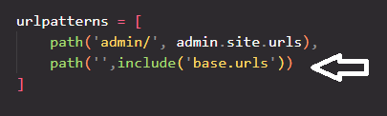

**29-navabr.html:**



**30-main.html:**





**Result:**

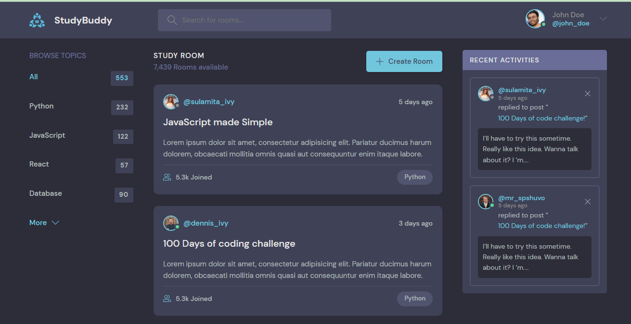

**Everything is good and home.html loads with its css styles correctly.**

**31-admin.py:**

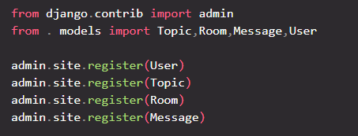

**32-create another superuser called tomy:**

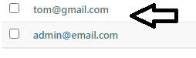

**33-create some topics:**

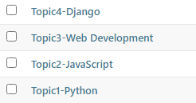

**34-create some rooms:**

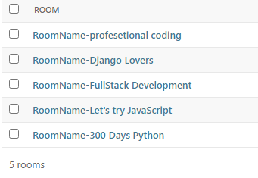

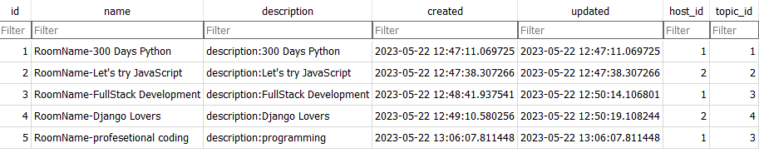

**35-create some messages:**

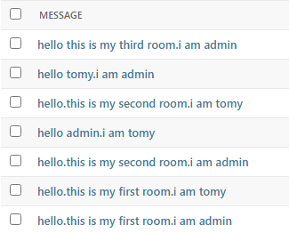

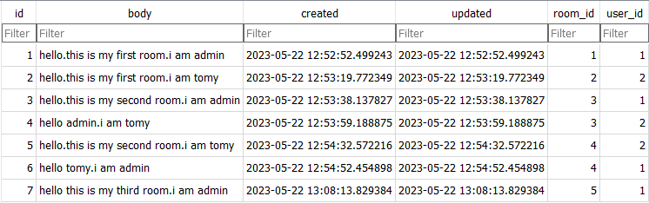

**36-view.py:**

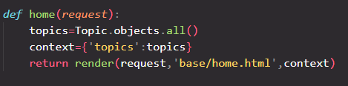

**37-home.html:**

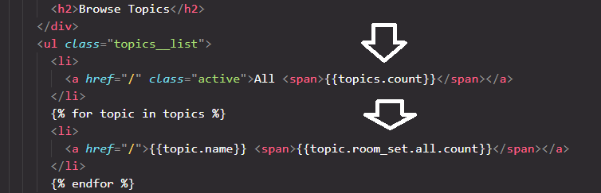

**Result:**

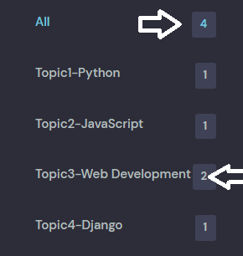

**I have created 4 topics and 5 rooms.for topic-1 and topic-2 and topic-4 I have created 1 room and for topic-3 I have created 2 rooms.so All must be 4 because I have 4 topics.**

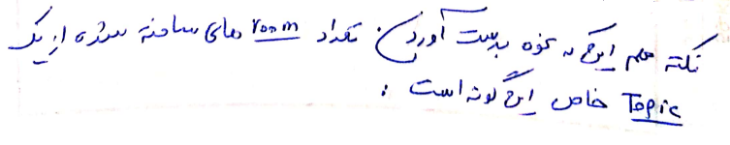

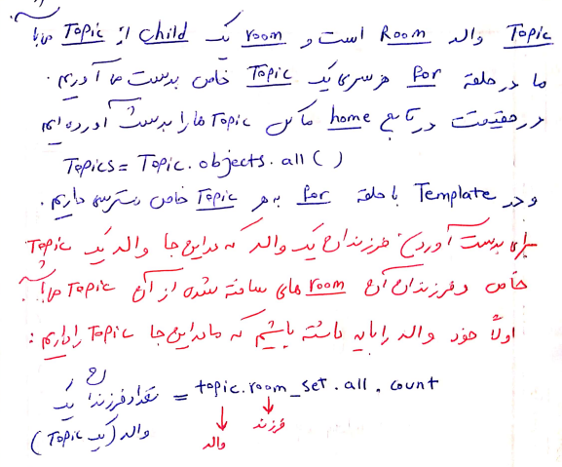

**38-topic filtering:**

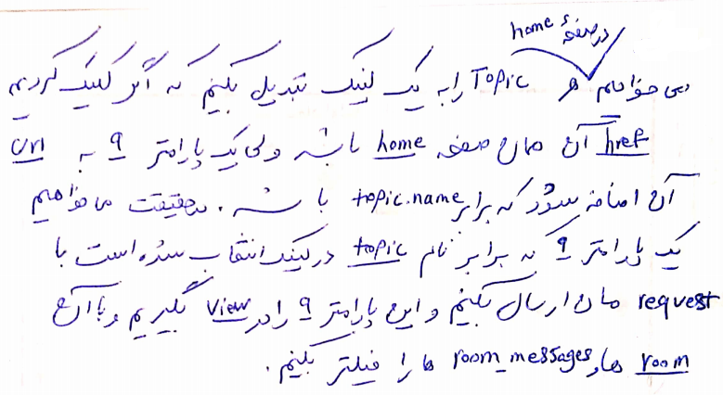

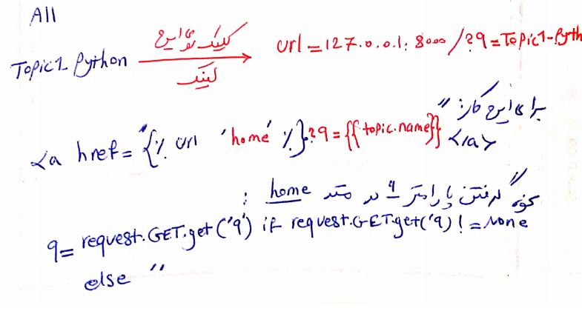

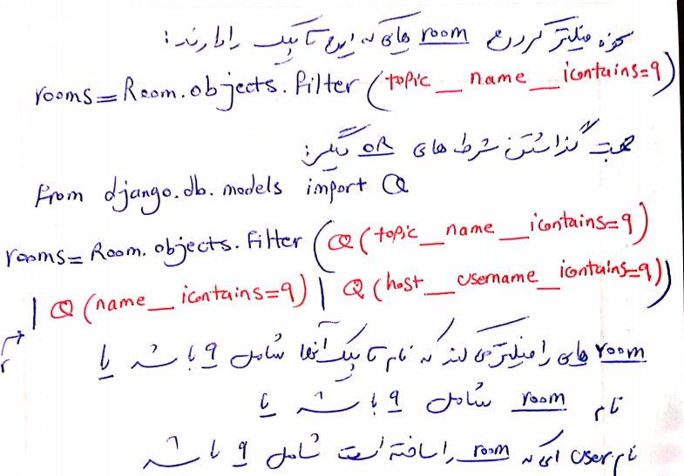

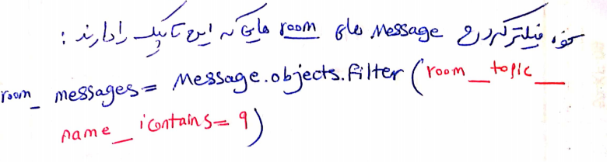

**39-views.py:**

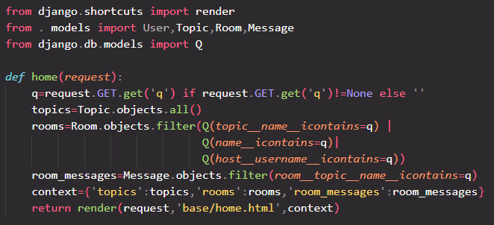

**40-index.html**

**We remove one of two:**

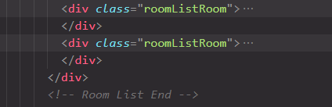

**Then we update this.for image:**



**for joined people to one room:**



**Result:**

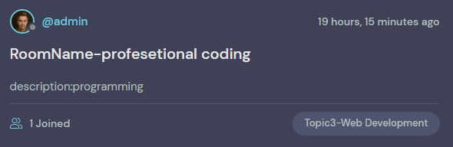

**41-recent activities:home.html:**

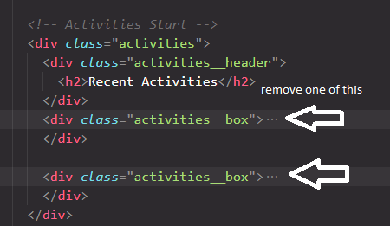

**for:**



**Image:**



**And other things are very simple.result:**

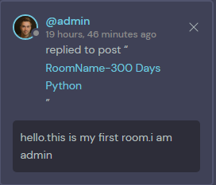

**And our topic filter works fine.for example filter for Topic3-Web Development:**

**url:**



**Filterd rooms:**

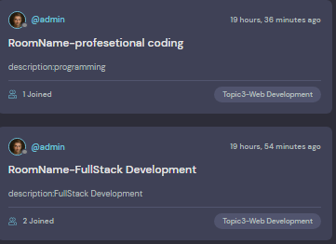

**Filtered recent activities:**

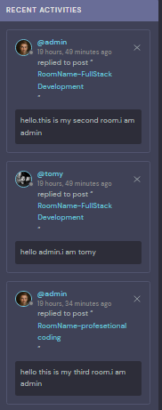

**42-room.html**

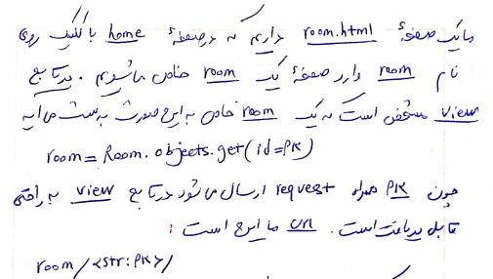

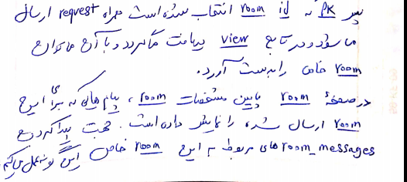

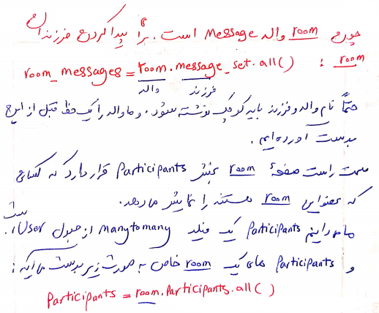

**Copy room.html from Requirements folder to templates/base folder.**

**room.html:**

**we keep just main tag and remove other things.**

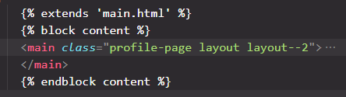

**views.py:**

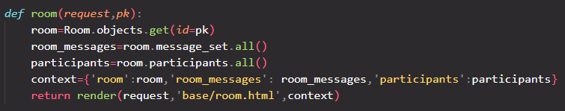

**urls.py:**



**Result:**

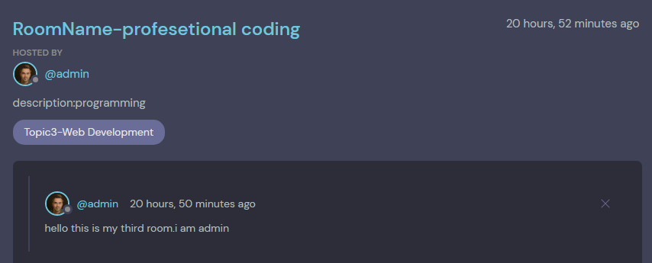

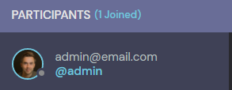

**For joined people:**



**For ring and image:**

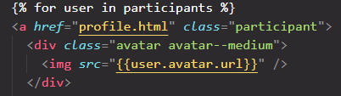

**Everything is good.**

**43-create room**

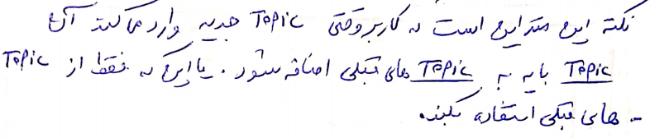

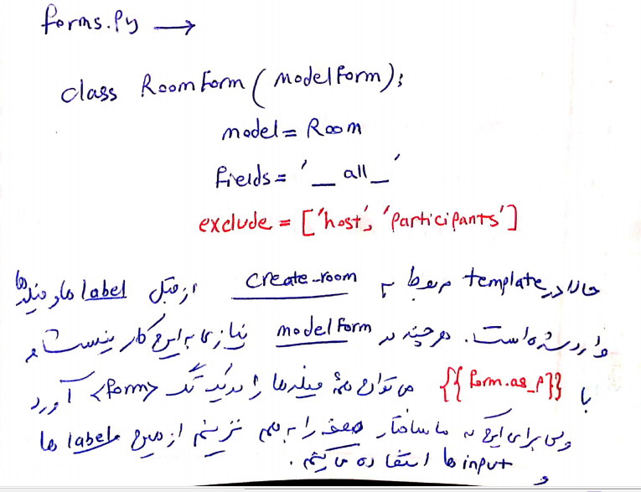

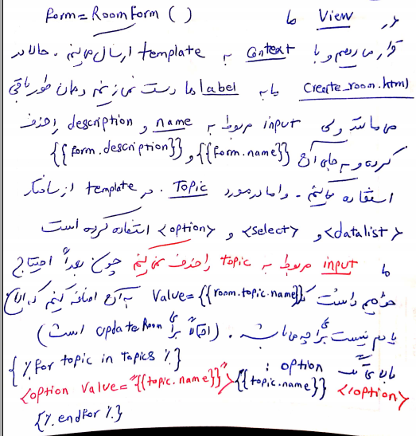

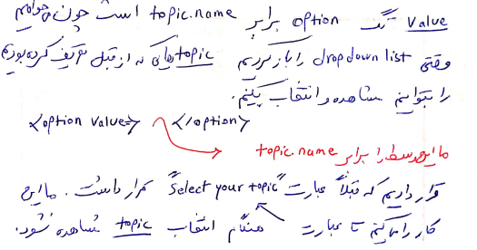

**forms.py:**

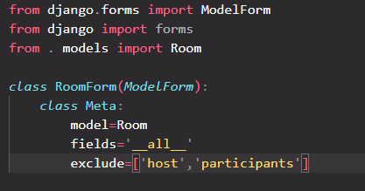

**urls.py:**



**views.py:**

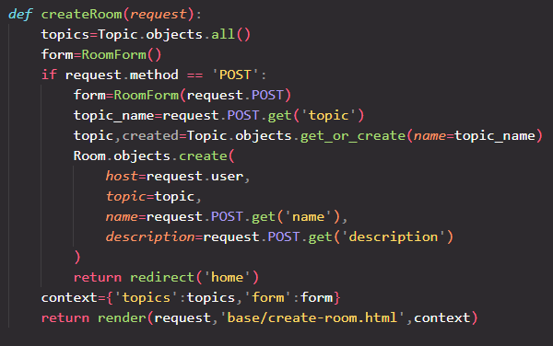

**And everything is good.**

**44-update room:**

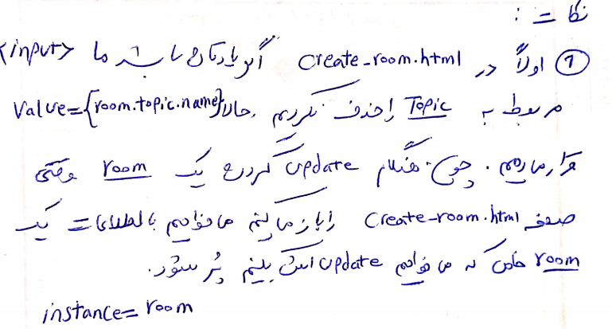

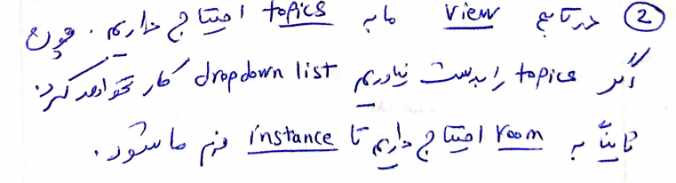

**create-room.html:**

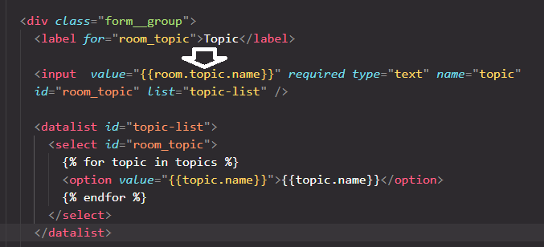

**urls.py:**



**views.py:**

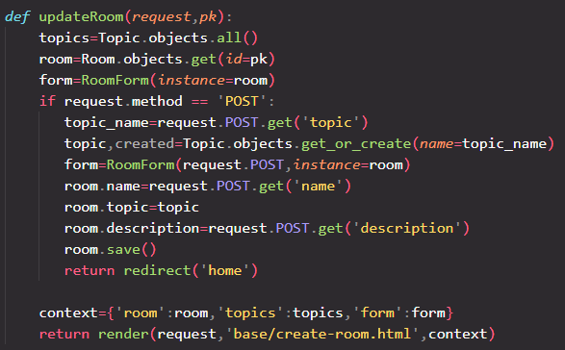

**And evrything works fine.**

**45-create activity_component.html and feed_component.html and topics_component.html**

**The move this section from home.html to them the use include in home .html:**

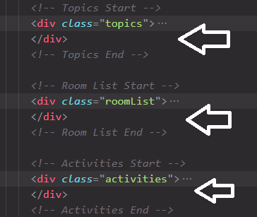

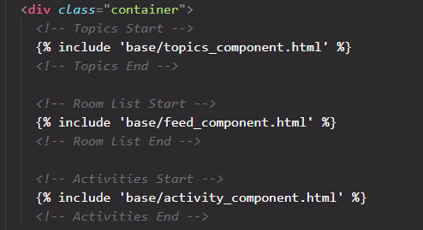

**46-user profile:**

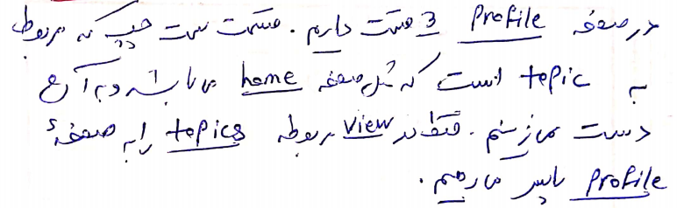

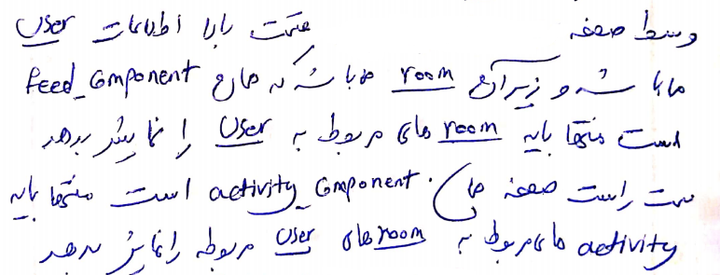

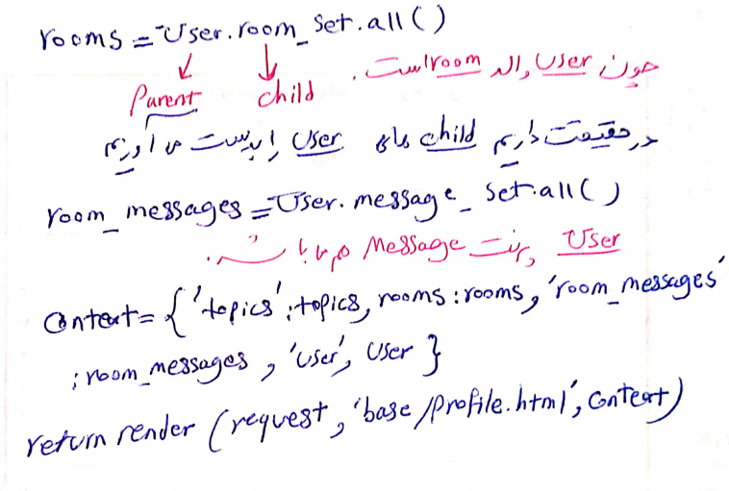

**urls.py:**



**views.py:**

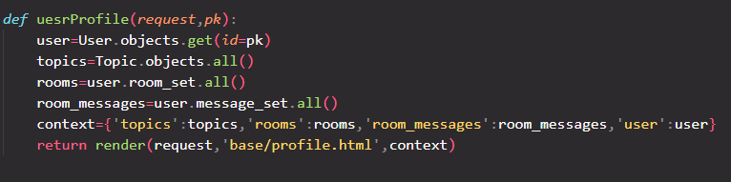

**47-login page and logout:**

**urls.py:**



**views.py:**

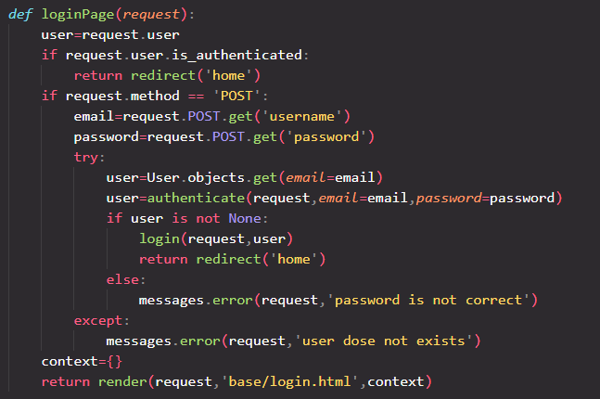

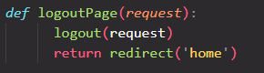

**navbar.html:**

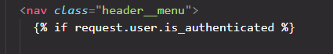

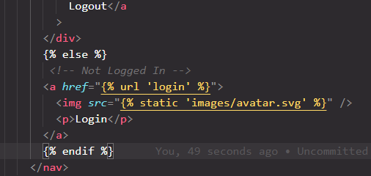

**main.html:**

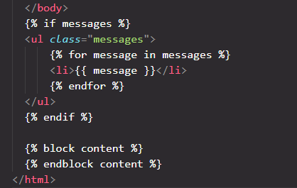

**Now we can login with email and logout.**

**48-update user:**

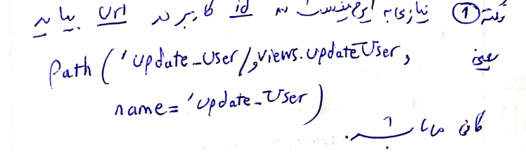

**urls.py:**



**forms.py:**

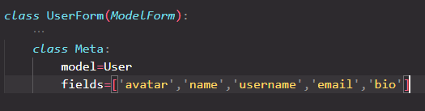

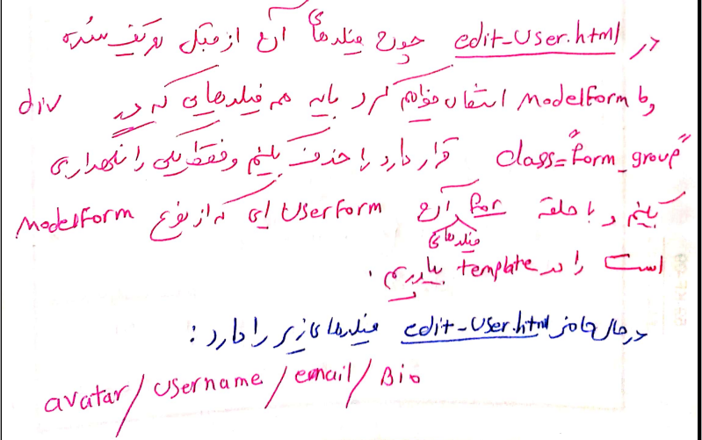

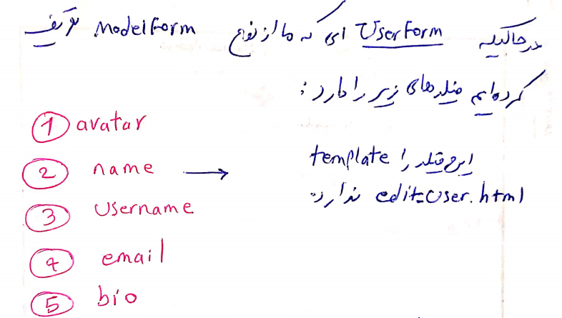

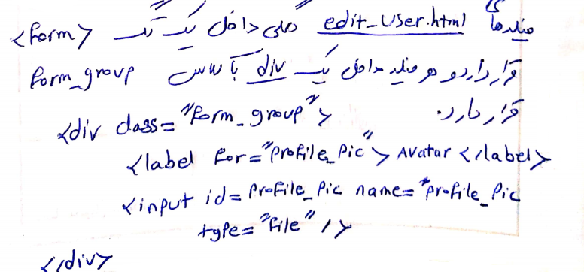

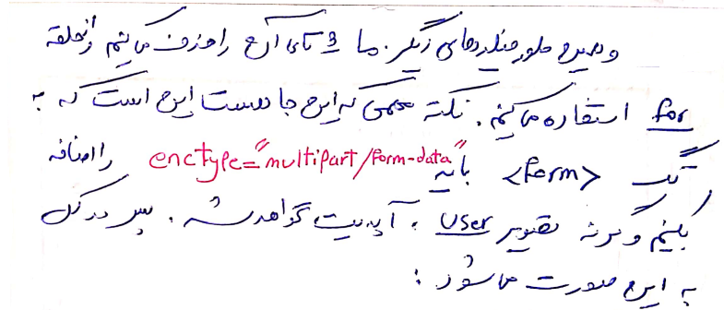

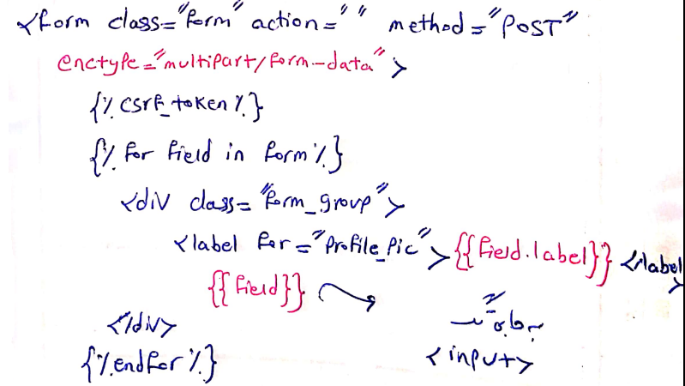

**views.py:**

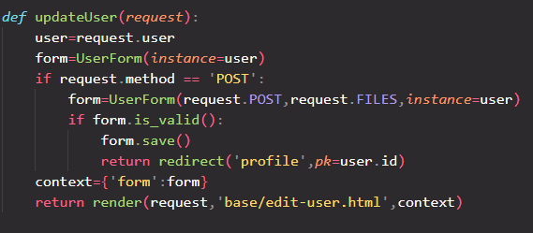

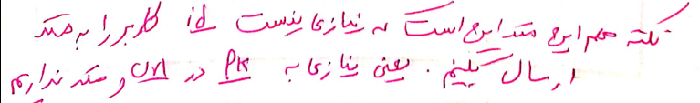

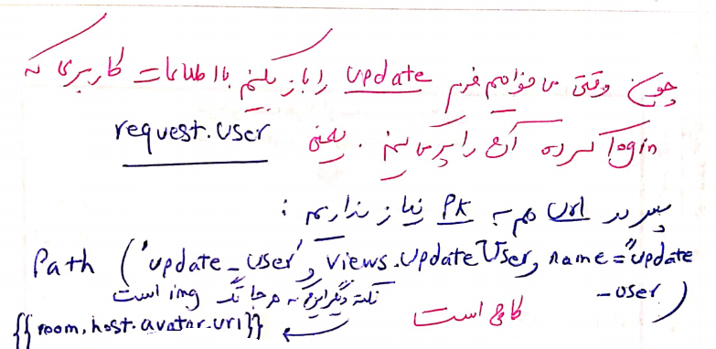

**49-register user:**

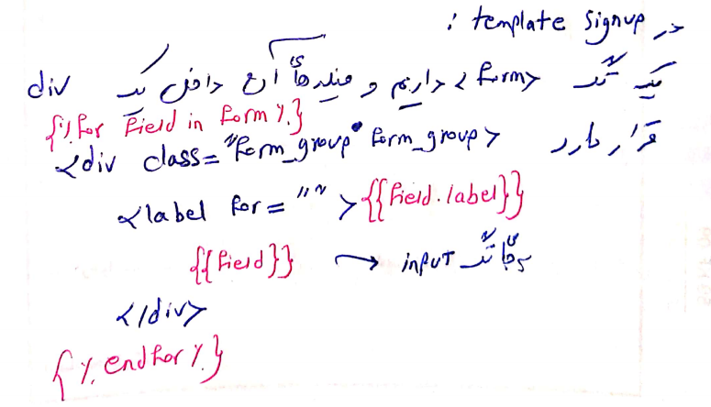

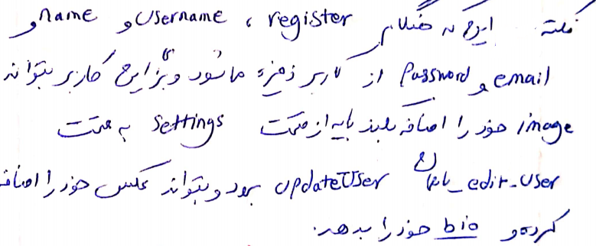

**urls.py:**



**forms.py:**



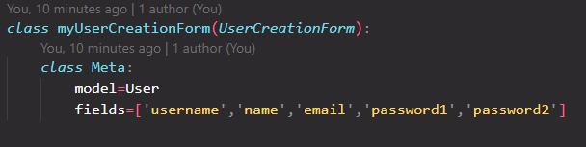

**views.py:**

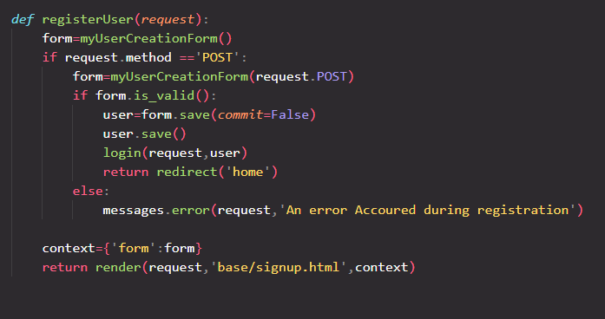

**50-topic page:**

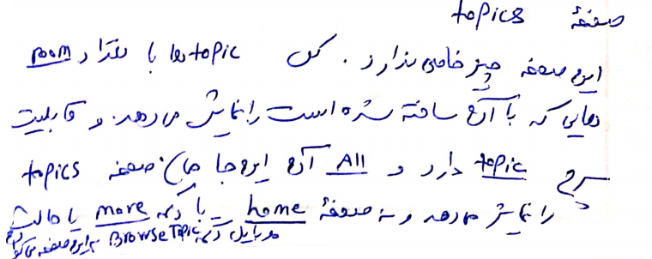

**urls.py:**



**views.py:**

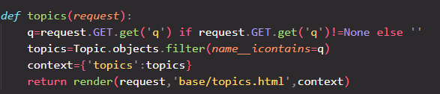

**topics.html:**

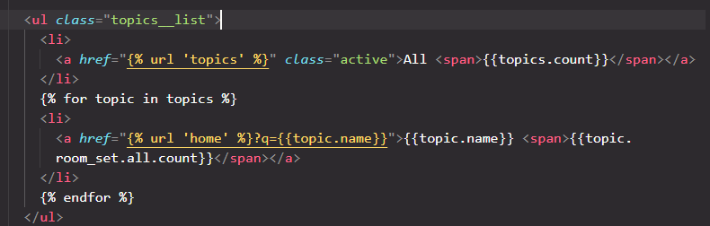

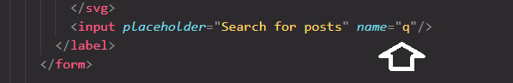

**And everything is good.**

**51-Recent Activities:**

**urls.py:**



**views.py**

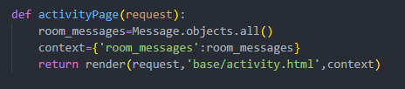

**Copy activity.html fille from Requirements folder inside templates/base folder.everything is work good.**

**52:delete room**

**Copy delete.html file from Requirements folder inside templates/base folder.**

**urls.py:**



**views.py:**

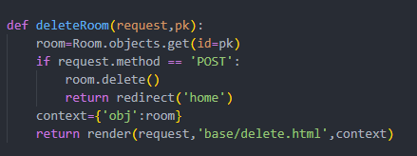

**delete.html:to return to previous page.because we use general delete page.**

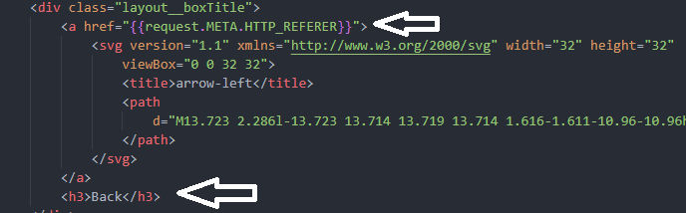

**And it works good.**

**53:write message in specific room:views.py:add this lines to room function:**

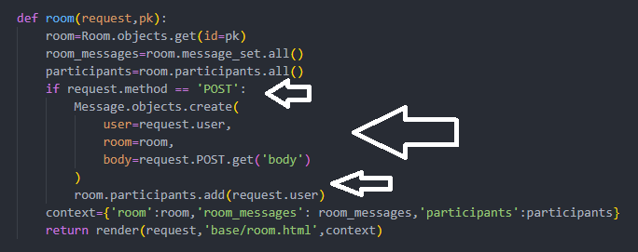

**room.html:**

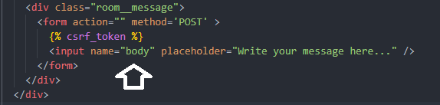

**And it works fine.**

**54-delete room messages:**

**urls.py:**



**views.py:**

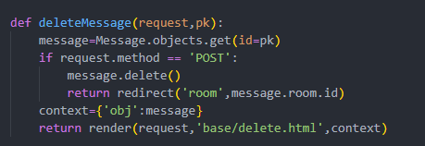

**And it’s work fine.**

**55-mobile version:**

**Feed_component.html:**

